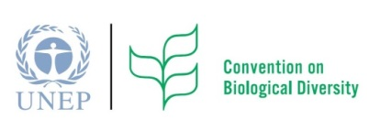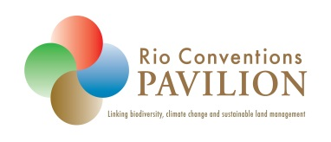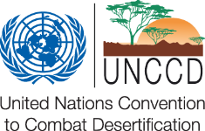
Ecosystem Restoration Day in the Rio Conventions Pavilion
Friday, 20 September 2013 @ 15:00 – 16:30
The Potential Contribution of Ecosystem Restoration
to Zero Net Land Degradation
World leaders at the Rio+20 agreed to strive for a land-degradation neutral world. It is an ambitious goal that needs to be translated into deliverable targets at national, regional and international levels. Thus the UNCCD’s advocacy for a post-2015 sustainable development goal on a land-degradation neutral world and an associated target on Zero Net Land Degradation are key to translating this ambition into actionable targets. One of the key elements of a land-degradation neutral world is the conservation and sustainable use of biodiversity and ecosystem services, but equally important is the restoration and rehabilitation of degraded ecosystems, as highlighted in the Hyderabad Call for a Concerted Effort on Ecosystem Restoration at CBD COP11.
Schedule
Session Moderator: David Ainsworth, CBD secretariat
15:00 – 15:15 Keynote Address: Uriel Safriel, Co-Chair of the Israel National Ecosystem Assessment Project
15:15 – 15:30 Response: Sakhile Koketso, CBD secretariat
15:30 – 16:10 Panel Discussion
Sasha Alexander, UNCCD; Jonathan Davies, IUCN;
Nora Berrahoumi, FAO; Malta Qwathekana, Ramsar; Representatives of UNDP and GEF (TBC)
16:10 – 16:30 Views from the Audience
Ecosystem Restoration Day in the Rio Conventions Pavilion
Friday, 20 September 2013 @ 15:00 – 16:30
The Potential Contribution of Ecosystem Restoration
to Zero Net Land Degradation
World leaders at the Rio+20 agreed to strive for a land-degradation neutral world. It is an ambitious goal that needs to be translated into deliverable targets at national, regional and international levels. Thus the UNCCD’s advocacy for a post-2015 sustainable development goal on a land-degradation neutral world and an associated target on Zero Net Land Degradation are key to translating this ambition into actionable targets. One of the key elements of a land-degradation neutral world is the conservation and sustainable use of biodiversity and ecosystem services, but equally important is the restoration and rehabilitation of degraded ecosystems, as highlighted in the Hyderabad Call for a Concerted Effort on Ecosystem Restoration at CBD COP11.
Schedule
Session Moderator: David Ainsworth, CBD secretariat
15:00 – 15:15 Keynote Address: Uriel Safriel, Co-Chair of the Israel National Ecosystem Assessment Project
15:15 – 15:30 Response: Sakhile Koketso, CBD secretariat
15:30 – 16:10 Panel Discussion
Sasha Alexander, UNCCD; Jonathan Davies, IUCN;
Nora Berrahoumi, FAO; Malta Qwathekana, Ramsar; Representatives of UNDP and GEF (TBC)
16:10 – 16:30 Views from the Audience

